Scatter to Serve God & Neighbor
Welcome to all! We gather to praise God for the innumerable blessings given
to us and to grow deeper in the Spirit. Joyfully, let us lift our hearts to God.



DIRECTORY OF CHESTNUT HILL UNITED METHODIST CHURCH
 | Sharma Lewis | Richmond Area Resident Bishop
 | Denise Bates | Lynchburg District Superintendent
 | Adam White | Minister
 | Steve Stadtherr | Associate Minister
 | Monica Campbell | Administrative Assistant
 | Heather Wilson | Director of Music Ministry
 | Judy Martin | Bookkeeper
 | Judy Robertson | Lay Leader


Chestnut Hill
United Methodist Church

Making disciples of Jesus Christ
for the transformation of the world.
You are welcome at Chestnut Hill UMC.

4660 Fort Avenue ~ Lynchburg, Virginia 24502
Church: 434-239-8423
Minister’s Cell: 434-944-7723, Minister’s Email: awhite@ves.org
Associate Minister’s Cell: 434-841-2458
Associate Minister’s Email: sps83.ss@gmail.com
chestnuthillumc@comcast.net ~ on the web at chestnuthillumc.net
Find us on Facebook: Chestnut Hill United Methodist Church

Chestnut Hill United Methodist Church
10:30 a.m. ~ February 27, 2022 ~ Transfiguration Sunday
Our ministry vision for the Virginia Annual Conference is “to be disciples of Jesus Christ who are lifelong learners, who influence others to serve.”
Welcome! Join us in worshiping God!
Prelude
Welcome and Ministry Announcements
Welcome in the name of Christ our Lord.
Thank you for silencing cell phones as we gather to worship God.
Invocation
Greeting
Christ upon the mountain peak
stands alone in glory blazing;
let us, if we dare to speak,
with the saints and angels praise him.
Trembling at his feet we saw
Moses and Elijah speaking.
All the prophets and the Law
shout through them their joyful greeting.
Swift the cloud of glory came.
God proclaiming in its thunder
Jesus as his Son by name!
Nations cry aloud in wonder!
This is God’s beloved Son!
Law and prophets fade before him;
First and last and only One,
Let creation now adore him! (Brian Wren, 20th century)
*Singing Our Faith # 374 “Standing on the Promises”
Opening Prayer
O God, who before the passion of your only-begotten Son revealed his glory upon the holy mountain: Grant to us that we, beholding by faith the

light of his countenance, may be strengthened to bear our cross, and be changed into his likeness from glory to glory; through Jesus Christ our Lord, who lives and reigns with you and the Holy Spirit, one God, for ever and ever. Amen.
Greeting Friends and Neighbors
Prayer for Illumination
O Lord, on this Sunday of Transfiguration, we pray that your light would pour over these pages and illumine these old, old words — that they would dance with newness in our hearts and minds, that we would be radiant in reflecting your Word in our living and serving one another. Amen.
Scripture Lessons 2 Corinthians 3:12-4:2 and Luke 9: 28-36, (37-43a)
The Word of God for the people of God.
Thanks be to God.
Singing Our Faith # 707 “Hymn of Promise”
The Good News “Something Old, Something New, Something Borrowed”
Special Music “When I Survey the Wondrous Cross”
Bringing Forward God’s Tithes and Our Gifts
*Doxology # 95 Praise God from whom all blessings flow; praise him, all
Creatures here below; praise him above, ye heavenly host; praise Father, Son, and Holy Ghost. Amen.
Prayer of Thanksgiving
Sharing of Joys and Concerns
The Lord’s Prayer
Our Father, who art in heaven, hallowed be thy name. Thy kingdom come,
Thy will be done on earth as it is in heaven. Give us this day our daily bread and forgive us our trespasses, as we forgive those who trespass against us. And lead us not into temptation, but deliver us from evil. For thine is the kingdom, and the power, and the glory, forever. Amen.
*Singing Our Faith # 389 “Freely, Freely”
*Blessing and Dismissal
*Postlude

**Calendar**
Wednesday, 3/2 | 5:00 p.m. | Ash Wednesday Service
Thursday, 3/3 | 6:30 p.m. | Choir
Friday, 3/4 | 10:00 a.m. | Homeschool
** Looking Ahead on the Calendar **
Wednesday, 3/9 | 10:30 a.m. | Merry Martha’s  We will meet at church for a short business meeting, than go to lunch at 11:30 a.m. at Charley's (707 Graves Mill Rd.). Please let Judy know whether you plan to attend.
Monday, 3/14 | 7:00 p.m. | Wesleyan Group  We will meet at the home of Linda Jessen.
Sunday, 3/20 | 11:45 a.m. | Stewardship Luncheon

In the Grocery Cart This Month
For February/March~The homeless seeking help have increased so we are continuing with bags filled with the following: soups, canned meats, ravioli, and breakfast bars. Make sure the canned goods have pop top lids so they can be opened easily.
Place donations in the grocery cart, located in the Commons.
**NOTE: Please put all liquids in the box provided. Tape down all flip top bottles. AND no “baked goods” of any kind.
Souper Bowl of Caring
We are participating in Souper Bowl of Caring to benefit Meals on Wheels. We are asking for donations during the month of February. Use a pew envelope and mark it “Souper Bowl of Caring” or “Meals on Wheels”.

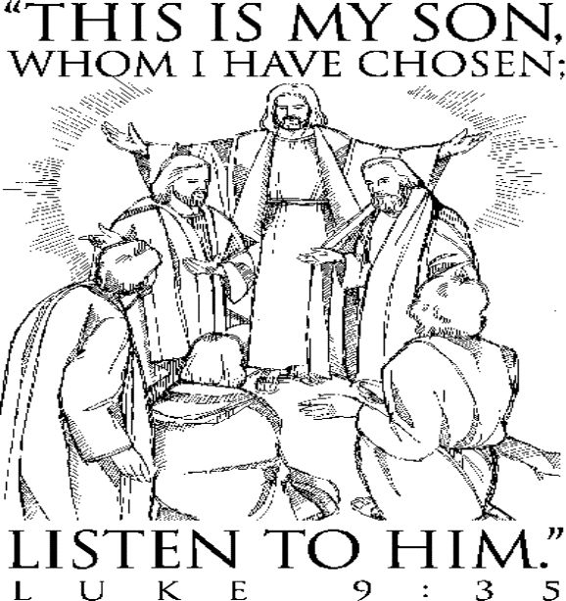
**Calendar**
Wednesday, 3/2 | 5:00 p.m. | Ash Wednesday Service
Thursday, 3/3 | 6:30 p.m. | Choir
Friday, 3/4 | 10:00 a.m. | Homeschool
** Looking Ahead on the Calendar **
Wednesday, 3/9 | 10:30 a.m. | Merry Martha’s  We will meet at church for a short business meeting, than go to lunch at 11:30 a.m. at Charley's (707 Graves Mill Rd.). Please let Judy know whether you plan to attend.
Monday, 3/14 | 7:00 p.m. | Wesleyan Group  We will meet at the home of Linda Jessen.
Sunday, 3/20 | 11:45 a.m. | Stewardship Luncheon
In the Grocery Cart This Month
For February/March~The homeless seeking help have increased so we are continuing with bags filled with the following: soups, canned meats, ravioli, and breakfast bars. Make sure the canned goods have pop top lids so they can be opened easily.
Place donations in the grocery cart, located in the Commons.
**NOTE: Please put all liquids in the box provided. Tape down all flip top bottles. AND no “baked goods” of any kind.
Souper Bowl of Caring
We are participating in Souper Bowl of Caring to benefit Meals on Wheels. We are asking for donations during the month of February. Use a pew envelope and mark it “Souper Bowl of Caring” or “Meals on Wheels”.

